**Modelling the topography of the ancient Lavrion: epigraphical sources, mental maps and GIS**

***Abstract***

In this contribution, we present an attempt to approach the past landscape of the Lavrion area, considering inscriptions dated to the 4th cent. BCE, recording the leases of the mines by the Athenian polity to individuals (the *poletae* record), as mental maps. The research aim is threefold: first, to reconstruct a flexible set of abstract mental maps, beyond a defined geometric space, in order to explore the network of spatial relationships defined in the epigraphical record and the social and economic meanings involved; second, to develop a methodology for the production of an “intermediate” map, spatially and geometrically correct, which transforms the mental map into an intra-referential map; third, final goal is to proceed to a reconstruction (insofar it is possible) of the landscape and the topographical layout of the area as in the 4th cent. BCE.

***Riassunto***

In questo contributo, presentiamo un tentativo di avvicinamento al paesaggio antico dell'area del Lavrion, in Attica, prendendo in considerazione come mappe mentali alcune iscrizioni datate al IV secolo a.C., la lista dei *poletae*, che registravano gli affitti delle miniere da parte del sistema politico ateniese ad individui. Lo scopo della ricerca è triplice: in primo luogo, ricostruire un insieme flessibile di mappe mentali astratte, al di là di uno spazio geometrico definito, al fine di esplorare la rete di relazioni spaziali definita nella registrazione epigrafica e i significati sociali ed economici coinvolti; in secondo luogo, sviluppare una metodologia per la produzione di una mappa “intermedia”, spazialmente e geometricamente corretta, che trasformi la mappa mentale in una mappa intra-referenziale; in terzo luogo, obiettivo finale è quello di procedere ad una ricostruzione (per quanto possibile) del paesaggio e dell'assetto topografico dell'area come si presentava nel IV secolo a.C.

*Keywords:* Mental maps, GIS, epigraphy, Lavrion mines, landscape.

In this contribution, we present a research plan to explore what we could perceive as an “ancient landscape”, considering a certain epigraphic corpus as a source for touching upon ancient mental maps. It is aimed that the decoding of the structural principles of these maps will provide a key for translating the ancient map to a modern one, employing a GIS platform; the reconstruction of past mental maps in a GIS environment has been a challenge since the late ‘90s[1].

Next step is the development of links to present day topography obtaining a deeper understanding of the landscape palimpsest as the bearer of a diachronic thread of shared spatial values. A first corollary of such an understanding will be a potential identification of certain material features of past “taskscapes”[2], recorded in the inscriptions, with presently observable material remains. A second, will be to apprehend the landscape we experience today as integral part of the socioeconomics of a past society.

The reason for presenting this research attempt, at such a preliminary stage, is to stir a discussion on the proposed methodology and develop a ground for potential collaboration which would link cases analogous to the one presented here. Thus we may ultimately arrive at a generally applicable tool.

The landscape to be explored, as a case study, is the palimpsest of the ancient-to-modern mining district of Lavrion in Attica, combining strong visibility of the remains of mines and workshops with technology-laden materials; the certain epigraphic data to be analysed derive from the *Poletae* records inscriptions (see below), dated in the 4th cent. BCE (mainly in its second half).

Our methodological premises are built upon a consensus developed ever since Merleau-Ponty’s body-space phenomenology(1945)[3] and Piaget’s schemas(1952)[4], that the experience and the subsequent learning of the landscape, in its three dimensional setting, is both generated by bio-physiological conditions (e.g. sensory organs) and structured via socio-cultural factors. The latter emerge at the intersection between the individual, groups and society, that is, their corresponding mentality, as circumscribed by the Annales School[5]. Within this frame of reference, places may be defined, for example, as such on the differential basis of intentions, naming, recurrent use or peculiar characters. Place-names belong to human perception processes, as people get acquainted with places giving them names[6]. Mental maps are the products of learning the landscape in the above manner. They are continuously generated by individuals experiencing a landscape. Collectivities share similar mental maps regulated by shared conventions which reside in the aforementioned mentality. Fundamental relational values such linked to orientation may be shared by more than a few collectivities.

***The Poletae records and the Lavrion Landscape***

*The inscriptions*

The *poletae* fragmented inscriptions were excavated in the Athenian Agora or nearby and their chronologies all all fall in the period between 367 and 300-295 BC. They are official documents, once erected in the Agora, recording public property contracts; among them (the most prominent, in terms of numbers of record-entries and extent of inscribed text) are the leases of the Lavrion mines[7]. There is standardisation, by record-entry, in registering this practice of leasing mines to individuals by the Athenian polity (**table 1**): each entry is structured by the mine’s name (A) and its class[8], usually the territorial Deme, a typically repeated location description (B, C, D1-4), which is our focus here, the lessee’s name and demotic and the fee payable (E). In this manner, catalogues of named mines are produced, with their location described by a systematic mode of reference to geomorphological and anthropogenic features bordering them in all four directions (E, W, N, S). A series of place-names, physical features and land-tenures or ownerships are mentioned, some of which are recurrent. A few match with available archaeological data or modern landscape features and can be located in modern geographical space with various degrees of precision[9].

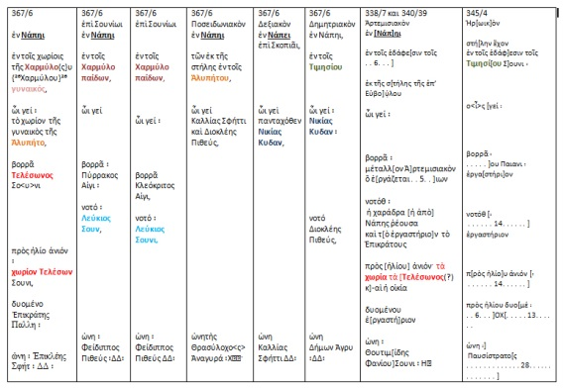

**Table 1** An example of the spatial relationships recorded in the *poletae* record as for the Lavrion area and the 4th C BC metallurgical workshops. —- **Replace with table 1 ATTACHED TO EMAIL**

*The Lavrion landscape*

When someone decides to start reading the book of the Lavrion landscape palimpsest, the sensory organ, the most appropriate, is his or her body moving into and within the landscape. The scale in which material remains (mainly of the classical times and of the 19th and 20th century mining companies) unfold, is overwhelming, as is their density, an effect that is multiplied once someone enters the underground world of mining galleries and shafts. In this labyrinth, you need an Ariadne’s thread: a map and landmarks. Among the notional diachronic threads which permeate the Lavrion palimpsest, stitching it to its integrity, the most prominent are geology, ore, metals, metallurgy and the need for guidance into them.

In the late19th and early 20th centuries the mining and metallurgical companies involved into the exploitation of ancient *scoriae* (slugs) and other ore and metallurgical by-products, worked meticulously to this direction. Together with their production project, the need for large areas to be conceded by the Greek state, generated maps and landmarks erected on the ground (fig. 1b)

Fig.1a shows a map of of the Lavrion Peninsula recording the distribution of ancient *scoriae* and tailings. The map was employed during the agile discussions in the Greek Parliament, in 1860s, or in 1880s on the terms and conditions for the ancient mining and metallurgical byproducts (scoriae and tailings) to be conceded to Serpieri and Roux Co. The vertices of this polygon were materialised on the landscape by the build cylindrical features known as the “Serpieri Horoi” (fig.1b).

In an analogous manner, the leasing of the Lavrion mines by the *Poletae*, demanded their spatial designation by landscape description and land marking. Fig. 2a and b show *stelae* known also as *metalla horoi,* which were erected close to the mine entrances, recording the name of the mine and the lessee’s name as well as the class of the mine.

**Fig 1**:

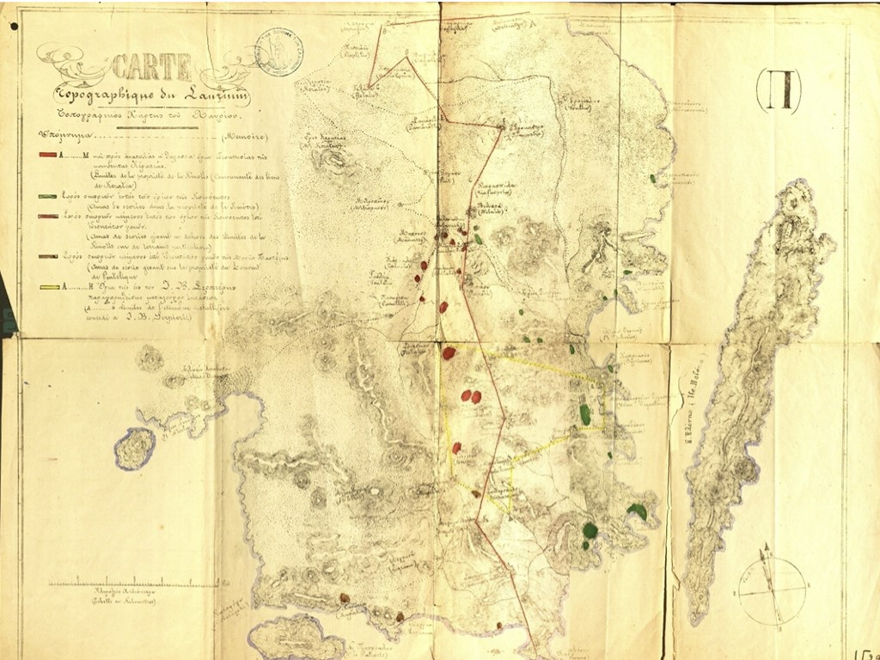

**1a.** Map of the Lavrion Peninsula (second half of the 19th century CE) recording the distribution of ancient scoriae and tailings. Red, green and brown areas signify large concentrations of these materials. The red polygon outlines the administrative border between two communities. The yellow polygon marks the area conceded to a private company to exploit ancient residues (source: The Hellenic Parliament Library, Map Collection).

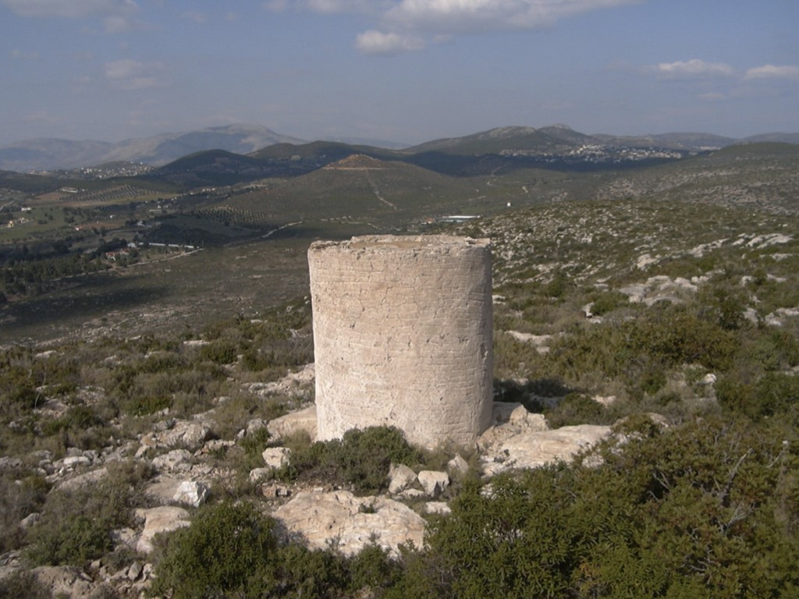

**1b**. One of the build cylindrical features known as the “Serpieri Horoi”.

**Fig. 2**

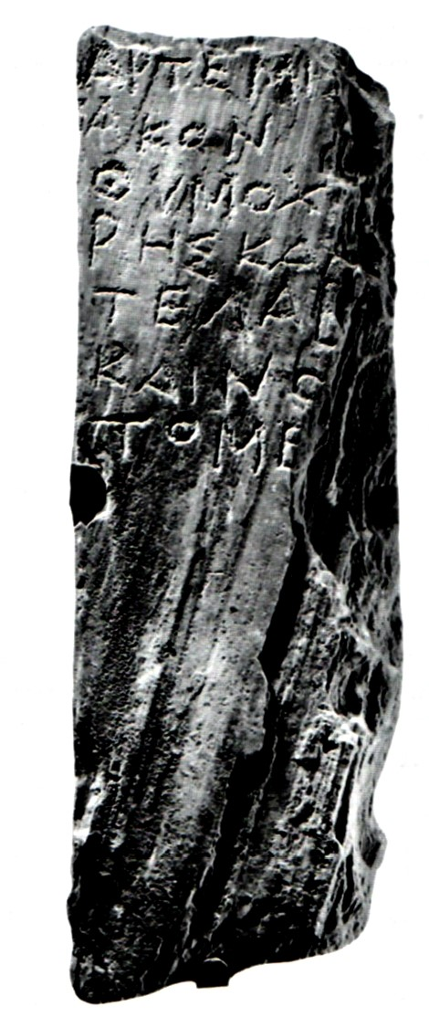

**2a**A stele inscription of the “dhelotikai” class (επιγραφαί δηλωτικαί μεταλλείων, Kakavogiannis 2005, 39-86). Such *stelae* were known as *metalla horoi.*

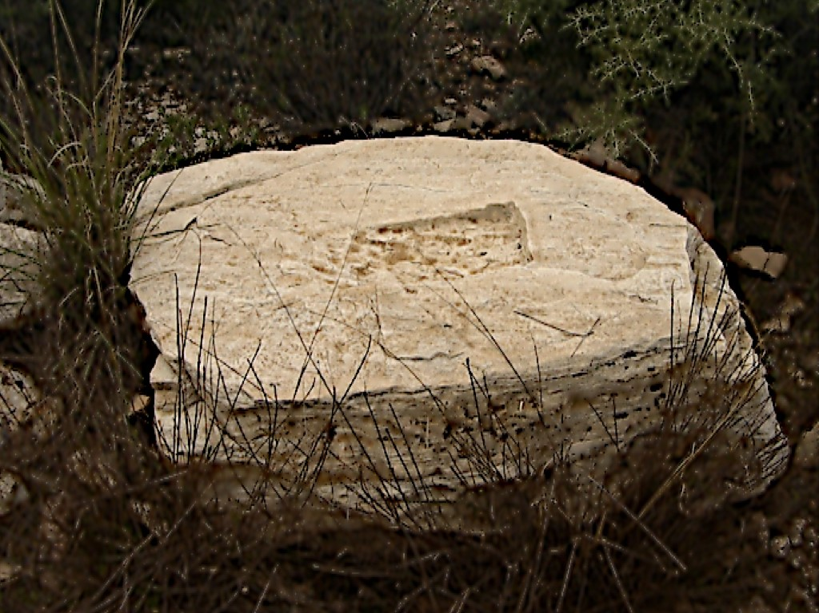

**2b** A stone base of a stele *in situ*, by the entrance of a mine[10]. In the specific example:

Αρτεμισ[ι]-

Ακόν

Θυμοχ[ά]

ρης κα-

τέλαβ[ε]

Καινο-

τόμε[ιαν]

vacat

(Transl.: *Thymochárês took over the Artemissiakon mine, which is a new venture)*

**Reading the Lavrion Landscape**

As Muir[11] points out, «in the course of sensing, the mind simplifies complex environmental reality into an environmental image». In a certain way, the Lavrion inscriptions report a somehow simplified image of the real landscape setting, allowing us to open a window into the shared mental map of the community which produced them: the scribes, the *poletae*, the bureaucracy they belonged to, the lessees and eventually the Athenian citizens who would read them in the Agora, shared conventionalities residing in the mentality of the Athenian society.

The density and scale of the material culture in the area triggers to the reader of the Lavrion landscape (who, at the same time, is a reader of the *poletae* mine leasing records) a sense of familiarity.

When you squeeze your body among the ruins of ancient mines and workshops, you get the impression that in the same straightforward manner that you grasp their materiality, by merely stretching your hand, you could identify them by the name of owner or lessee, and identify the landscape you move within with the landscape that emerges from within the *poletae* inscriptions.

Why is this? Because we share with the composers of the inscription texts certain mental map structuring principles[12]: orientation and reference to geomorphological features.

ηλίου ανιόντος – [to the side of the] rising sun

ηλίου δυομένου [to the side of the] setting sun

Βορράθεν *from* the North

Νότοθεν *from* the South

(*four horizon-directions, fig. 2, D1-4*)

Λόφος (hill), Χαράδρα (cliff/gorge), Ποταμός (river/stream), Θάλασσα (sea), Οδός (road/route).

(*geomorphological features as landmarks*)

This does not equal that we share also the exact content of the terms used heuristically in implementing orientation and land marking. We could be close, though. And this feeling is augmented once we come across to a context which makes instantly the journey από το *ΣΗΜΕΙΟ* στο *ΤΟΠΙΟ* (from a spot to landscape) that is, from the microscale of a rock-surface, all the way through nested scales of reference, to the landscape scale[13].

*The project’s plan*

So far, in the relevant literature, the processing of the epigraphical data of the *poletae* records has targeted issues such as price statistics, mine categorization nomenclatureandprosopography[14].

In this project, it is attempted to reconstruct a flexible set of abstract mental maps, beyond a defined geometric space, in order to explore the network of spatial relationships defined in the epigraphical record and the social and economic meanings involved. In achieving this, we have planned and have begun to follow a four step process:

First, the construction and implementation of a database to investigate the “intermediate” logical network of relationships, which transforms the *poletae* records mental map into an intra-referential network (fig.3).

Second, the discrete discontinuous textual references analysed in their network links are transformed into a continuous virtual surface, with a virtual spatial dimension, in a virtual space defined by a matrix of cells.

Third, we should develop a methodology for the transferring of the intra-referential network into a spatially and geometrically correct “intermediate” virtual map. In other words, we should be able to perform the mathematical formation of a coherent and geometrically correct coordinate system of an intermediate virtual space (fig.4).

Fourth, to proceed to a reconstruction (insofar it is possible) of the landscape of the area as in the 4th cent. BCE, mapping the workshops and the physical features such as streams and ridges, by linking the intermediate map to the modern three-dimensional geo-topographical space, through the identification process of comparing archaeological data, especially rupestral inscriptions and *horoi*, and workshops and mine *stelae[15]* to the *poletae* inscription texts.

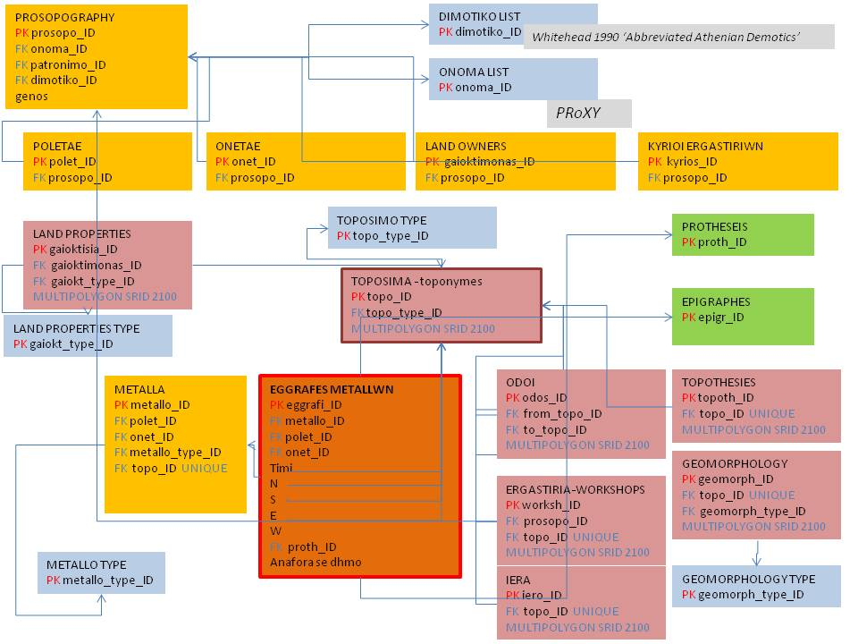

**Figure 3** The simplified ER model on which is based the Database implemented for the project.

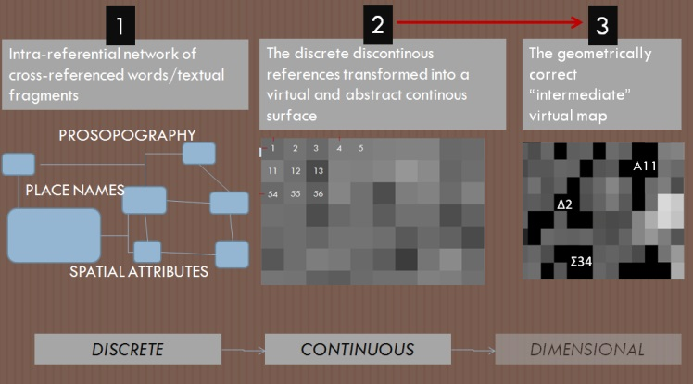

**Figure 4** The 4 steps of the process: from the *poletae* inscription to real landscape via the construction and the virtual representation of mental maps.

*The work so far*

As explained above, we first have to tackle the construction and implementation of a database to investigate the “intermediate” logical network of relationships, with the aim to convert the *poletae* records into an intra-referential network which will constitute our set of mental maps.

The implementation of the database (in SQL language in a Spatialite environment) is going to be a productive task on its own, allowing for the investigation of plenty of queries, on epigraphical issues and prosopography, as well as on social structures and processes, involving especially the relationships between landowners, workshop owners and mine lessees (*Onetae*), and the embodiment of the Athenian socio-economic structure (property management system). For our purpose we focus on: the relationship between prosopography and place names (involving mines, workshops, physical features such as ridges, streams and gorges), and the occurrence and use of particular prepositions in the indication of places (*en, epi, eis*).

The database records the indication of relative location of place names mentioned in the *eggraphes metallwn*, in the *Poletae* records. They show several possible combination of relative locations in space, marked by different degrees of complexity. For example, we may explore the potential to employ the recurrence of land owners or their relatives in conjunction with others, non-relatives, as indication of land proximity, applying the investigation of Proxy factors. Space, thus, reflects personal or family relationships and acquires a social dimension.

In this 1st step of the process we explore a network of discrete elements with a ‘relational’ spatial character.

In the second step, the discrete, discontinuous textual references, analysed in step one via their inner connections (intra-relationships by links of orientation, landmarks etc), are transformed into a continuous virtual surface, with a virtual spatial dimension, in a virtual space defined by a matrix of cells. Fig.4 shows the mathematical transformation of each quartet of orientations (N, S, W, E) defined in each *Poletae* record, in a Cartesian space, each cell defined by four vectors (V1,...V4) of the form V1=(1,0,0,0), V2=(0,1,0,0) V3=(0,0,1,0), V4=(0,0,0,1). Each digit of each quartet derives from the N-S-E-W set in the inscriptions; their value derive from the N4 group of IDs corresponding to unique places. Following this, the DataBase is queried in order to retrieve missing spatial information. For example:

if Ω is located East of Δ, then V3 (Δ)=Ω and V4(Ω)=Δ. Given the quartets as in fig.6, if anywhere in the QUARTETS a Γ is located in the 3rd place, the corresponding quartet would be the question mark and would fill a gap in the virtual map.

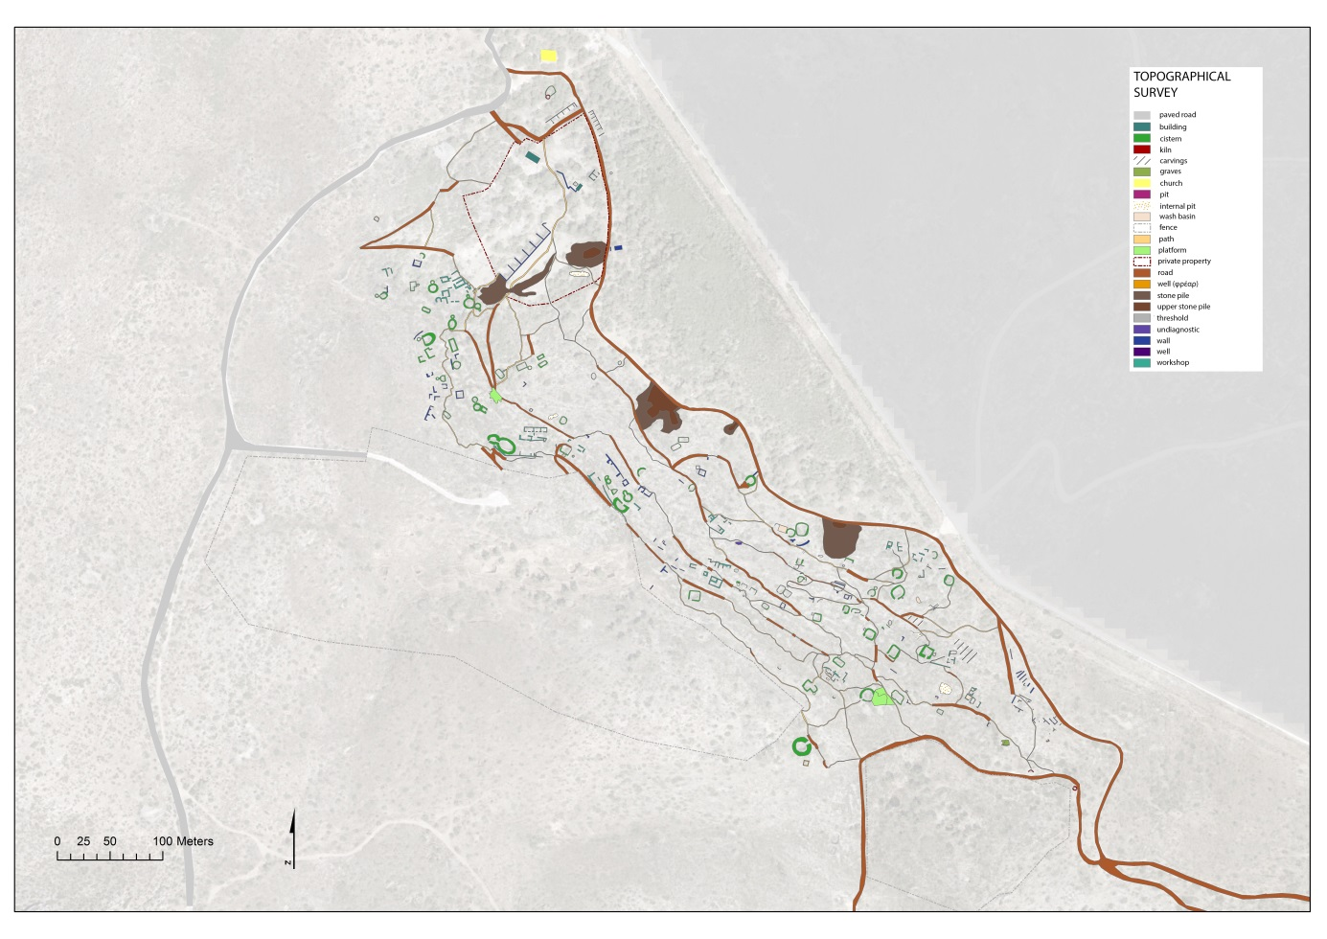

**Figure 5** GPS archaeological survey of the Souriza area (Lavrion), a topographical base useful for the reconstruction of the past real map of the ancient Lavrion.

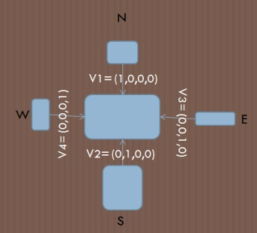

**Figure 6** The mathematical transformation in a Cartesian space, each cell defined by four vectors (V1,...V4) of the form V1=(1,0,0,0), V2=(0,1,0,0) V3=(0,0,1,0), V4=(0,0,0,1).

In step 2, the virtual representation of the investigated records is a matrix, which maps in a symbolic abstract virtual space the assignment of spatial attributes that cannot be defined yet. The construction of the matrix is based on an algorithm working in a Cartesian space where the transition among the cells is feasible only moving step by step from one cell to another.

The transition between step 1 and step 2 is allowed through the dynamic interconnection PLACE NAMES – PROSOPOGRAPHY - SPATIAL ATTRIBUTES, due to the incorporation in the inscriptions of the Athenian socio-economic structure (in the form of the prosopographical record linked to spatial features and place names). From text strings representing discrete features we move to cells that signify the link between the words and their spatial attributes.

In order to move on to step 3, we need to develop a methodology for the transferring of the intra-referential network into a spatially and geometrically correct “intermediate” virtual map. In other words, we should be able to perform the mathematical creation of a coherent and geometrically correct coordinate system. To move on to the third stage, and then to the fourth, we need to complete the first two stages and to resolve the matrix in all its possible components, in order to build up a proper topology of the Lavrion landscape.

**Perspectives**

The research presented here is still at its very initial stage; yet, we have attempted to set out the research framework and guidelines to move further. The methodology we are trying to prescribe could produce a decoding of the social dynamics linked to the landscape properties during certain periods: *poletae* records refer to the second half of the 4th cent.BCE; other inscriptions from the area, such as those of the *Salaminioi* move forward to the 3rd cent. BCE[16], while those of the sacrificial calendars expand the scope both earlier and later[17]. At this cross-road where the conjectural socioeconomic pattern of a certain community is perceived by agents-members of this community and implemented in the long-term dynamics of the landscape, we may also be able to unlock the understanding of further principles which structure ancient mental maps as intrinsic elements of the collective ideology of an ancient community, that is, its mentality.

**References**

Aperghis 1998: G.G. Aperghis, *A reassessment of the Laurion mining lease records*, «Bulletin of the Institute of Classical Studies», 42(1), 1-20.

Bathe 1976: K.J. Bathe, *Numerical methods in finite element analysis*, Prentice-Hall.

Bissa 2008: E. M. Bissa, *Investment patterns in the Laurion mining industry in the fourth century BCE*, «Historia: Zeitschrift für Alte Geschichte», H. 3, 263-273.

Bowden – Lowenthal 1975: M. J. Bowden – D. Lowenthal (eds.), *Geographies of the mind*, Oxford, Oxford University Press.

Crosby M. 1941: M. Crosby, *Greek inscriptions: a poletai record of the year 367/6*, «Hesperia» 10, 14-30.

Crosby M. 195: M. Crosby, *The leases of the Laurion mines*, «Hesperia»19, 189-312.

Crosby M. 1957: M. Crosby, *More fragments of mining leases from the Athenian agora*, «Hesperia»19, 189-312.

Daux 1980 : G. Daux, *Recherches préliminaires sur le calendrier sacrificiel de Thoricos*, «Comptes rendus des séances de l'Académie des Inscriptions et Belles-Lettre» 2, 463-470.

Daux 1984: G. Daux, *Sacrifices à Thorikos*, «The J. Paul Getty Museum Journal» 12, 145-152.

Ferguson 1938: W. S. Ferguson, *The Salaminioi of Heptaphylai and Sounion*, «Hesperia» 7, 1-74.

Farinetti – Cavallero 2019: E. Farinetti – F. Cavallero, *Mapping Roman Athens*, in *Spreading Excellence in Computer Applications for Archaeology and Cultural Heritage* ed. by P. Kyriakidis, A. Agapiou, V. Lysandrou, <https://gr.caa-international.org/wp-content/uploads/sites/26/2019/04/CAA-GR-2018-proceedings.pdf>

Guervich 2008: A. Guervich, *Approaches of the 'Annales School'. From the History of Mentalities to Historical Synthesis*. Scandia, Tidskriftförhistoriskforskning, 58(2).

Ingold 2000: T. Ingold, *The perception of the environment: essays in livelihood, dwelling and skill*, London-New York, Routledge.

Ingold T. 1993: T. Ingold, “The temporality of the landscape”, «*World Archaeology*» 25:2, 152-174.

Johnston 1998: R. Johnston, *Approaches to the perception of landscape: philosophy, theory, methodology*, «Archaeological Dialogues» 5, 54-68.

Kakavogiannis 2005: E. Kakavogiannis, *Μέταλλα Εργάσιμα Συγκεχωρημένα (The organisation of the exploitation of the Lavreotiki ores by the Athenian Democracy),* Dhemosieumata Archaeologikou Dheltiou 90, Athens, Ministry of Culture.

Kapetanios A. 2013: A. Kapetanios, Ο χώρος και οι άνθρωποι στην αρχαία τοπογραφία της Λαυρειοτικής *(Space and people in the ancient topography of Lavrion),* in *Archaeological Contributions, Vol. A’: Attica*, Museum of Cycladic Art, Athens, 183-198.

Langdon M.K. 1991: M.K. Langdon, *Poletai Records*, in *The Athenian Agora XIX. Inscriptions. Horoi. Poletai records. Leases of public land*, ed. by G.V. Lalonde, M.K. Langdon, M.B. Walbank, Princeton, 53-143.

Lalonde *et al* 1991: Lalonde V. *et al., Inscriptions: Horoi, Poletai Records and Leases of Public Lands,* Athenian Agora XIX, Princeton.

Leonardos 2010: I. Leonardos, *Statistical Analysis of the Mine Names in Ancient Laurion*, «Mineral Wealth»2010, 47-52.

Llobera 1996: M. Llobera, *Exploring the topography of mind: GIS, social space and archaeology*, «Antiquity» 70, 612-22.

Merleau-Ponty 1945: M. Merleau-Ponty, *Phénoménologie de la Perception,* Paris, Librairie Gallimard.

Muir 1999: R. Miur, *Approaches to landscape*, London, Palgrave Macmillan.

Piaget 1952: J. Piaget, *The origins of intelligence in children*. New York, International Universities Press.

Shipton 1998: K. Shipton, *The prices of the Athenian silver mines*, in *Zeitschrift für Papyrologie und Epigraphik*, 57-63.

Shipton 2000: K. Shipton, *Leasing and lending: the cash economy in fourth-century BC Athens*, «Bulletin of the Institute of Classical Studies», Supplement iii-14.

Tilley 1994: C. Tilley, *A phenomenology of landscape: places, paths and monuments*, Oxford, Berg.

Whitehead 1990: D. Whitehead, *Abbreviated Athenian Demotics*, in *Zeitschrift für Papyrologie und Epigraphik*, 105-161.

1. Llobera 1996; see Farinetti – Cavallero 2019.
2. Ingold 1993.
3. Merleau-Ponty 1945.
4. Piaget 1952.
5. Guervich 2008.
6. Bowden - Lowenthal 1965; Tilley 1994; Johnston 1998; Ingold 2000.
7. Crosby 1941; Crosby 1950; Crosby 1957; Lalonde et al. 1991.
8. Ανασάξιμον, εργάσιμον, συγκεχωρημένον, καινοτομία (for a discussion on the meaning of these terms, see Kakavogiannis 2005, 112-116).
9. Kapetanios 2013, 185-187.
10. Photo after Kakavogiannis 2005, 48, fig.7, ML961*.*
11. Muir 1999, 126.
12. Merleau-Ponty 1946, 112-132.
13. Kapetanios 2013, 189-192.
14. Aperghis 1997-1998, Shipton 1998, 2000, Bissa 2008, Leonardos 2010.
15. Kapetanios 2013, 185-187.
16. Ferguson 1938.
17. SEG 33:147, Daux 1980, Daux 1984.